TASK 6
Dataset Preparation and Preprocessing
Face Monitoring Model and Phone, Drink & Food Detector (YOLO26n), version 2

Project | Real-Time Driver Monitoring System (RTDMS)
Scope | Face monitoring (MediaPipe + EAR) and phone, drink and food detection (YOLO26 nano)
Prepared by | Youssef Medhat
Date | October 2026 (version 2, updated with the new datasets)
Programme | B.Sc. Graduation Project, Computer Engineering, AASTMT

Contents
1. Introduction 3
1.1 Summary at a glance 3
1.2 What changed since version 1 3
2. Face Monitoring Model 3
2.1 Datasets 4
2.2 Splitting 4
2.3 Preprocessing 5
3. Phone, Drink and Food Detector (YOLO26n) 6
3.1 How it works 6
3.2 Datasets we used 6
3.3 Organising the data 7
3.4 Labelling 7
3.5 Cleaning 7
3.6 Preprocessing 8
3.7 Splitting 8
3.8 Size and class balance 9
4. Progress: How It Went 10
5. Data Quality and Ethics 10
6. Assumptions and Limitations 11
7. Next Steps 11
8. References 11

1. Introduction
Our driver monitoring system uses two camera models:
- Face model: watches the eyes and head. It detects drowsiness and looking away.
- Object detector: finds a phone, a drink or food in the picture. It detects phone use, drinking and eating.
This report shows which data each model uses, and how we organised, labelled, cleaned, prepared and split it.

1.1 Summary at a glance
Table 1: The models and their data
Model | What it detects | Training data | Test data
Face model (MediaPipe + EAR) | Eye closure, blinks, PERCLOS [1], head pose, gaze | None needed (Google's ready model [2]) | CEW, 2,423 photos [3]
Eye-state CNN (comparison) | Eyes open or closed | MRL Eye, 84,898 IR images [4] | 8 MRL people never seen
Object detector (YOLO26n) [5] | Phone, drink and food boxes | 5 sources, 53,889 images | 10 new SynDD drivers + 2 unseen datasets

1.2 What changed since version 1
Why we changed the phone model
Version 1 used a ready image classifier trained on State Farm [16]: colour photos taken from the passenger side.
Our camera is infrared and sits at the centre mirror, so it sees the driver from a different angle.
We replaced it with an object detector. It draws a box around the phone, cup or food, so the system also knows where it is (for example, a cup at the mouth).

2. Face Monitoring Model
This part is unchanged since version 1. The face model finds 478 points on the face [2]. From them it measures how open the eyes are and where the head points. Simple rules then decide the driver state. It uses Google's pre-trained models, so it needs no training data; we use data only to test it.
Camera  640 × 480 frame | ▶ | MediaPipe  478 face points | ▶ | Measurements  EAR, head pose, gaze | ▶ | Rules  Blinks, PERCLOS | ▶ | Driver state  Alert / Drowsy / Distracted
Figure 1: Face model, from camera frame to driver state

2.1 Datasets
Table 2: Face datasets
Dataset | Size | Image type | Labels | Used for
CEW [3] | 2,423 face photos  (1,192 closed, 1,231 open) | Colour, 100 × 100 faces | Open / closed (folder name) | Choosing thresholds and testing
MRL Eye [4] | 84,898 eye images from 37 people | Infrared, grey eyes | 8 labels in each file name (eye state, glasses, light...) | Training the eye-state CNN

2.2 Splitting
CEW was split into a tuning set (30%), used only to choose thresholds, and a test set (70%), used only for the final score.
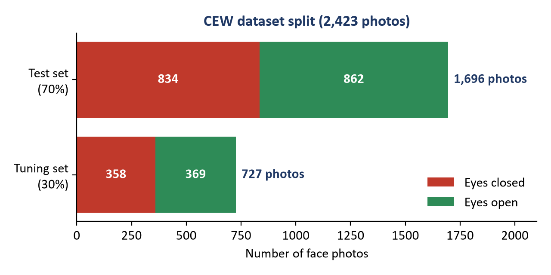
Figure 2: CEW split into tuning and test sets
MRL was split by person: nobody in the test set appears in training.
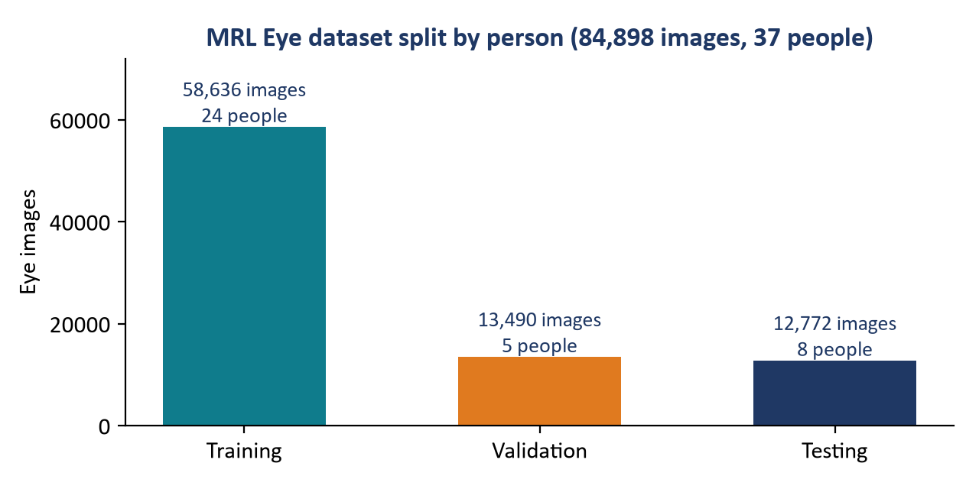
Figure 3: MRL split by person
Why split by person?
If the same person is in training and testing, the model can memorise that person, and the score looks better than it really is. Splitting by person gives an honest score for new drivers. We use the same rule for every dataset in this report.

2.3 Preprocessing
Table 3: Preprocessing of the face data
Step | Live camera frames | CEW photos (test) | MRL eyes (training)
Size | 640 × 480, 30 frames/s | 50% border added, then 400 × 400 | 32 × 32
Colour | RGB; at night grey → 3 channels + CLAHE contrast [14] | RGB | Grey
Normalisation | Inside MediaPipe; EAR [15] scaled to each driver's calibration | Inside each model | Per image: minus mean, divided by contrast
Cleaning | 3-frame median filter on EAR | - | -
Augmentation | None | None | 9 types (flip, rotate ±15°, zoom, shift, light, blur, noise...)

3. Phone, Drink and Food Detector (YOLO26n)

3.1 How it works
A small detector (YOLO26 nano, 2.5 million weights) looks at the driver and draws boxes around a phone, drink or food. Short rules turn the boxes into alerts.
Camera  Infrared, 1296 × 972 | ▶ | Driver area  Cut out the driver | ▶ | YOLO26n  512 × 512, grey | ▶ | Rules  Phone ≥ 1 s, cup at mouth | ▶ | Alert  Phone / drinking / eating
Figure 4: Phone, drink and food detector

3.2 Datasets we used
No single public dataset matches our camera, so we combined five training sources and kept two more datasets for testing only.
Table 4: Datasets for the object detector
Dataset | What it is | Size we used | How we used it
SynDD [6] | Acted driving video, infrared, camera at the mirror (like ours) | 69 drivers, 138 videos → 18,318 frames | Main training data + test (by driver)
Open Images V7 [7] | Everyday photos with boxes | 16,996 photos | Teaches what phones, cups and food look like
DMS_Project [8] | Driver-camera images, IR and colour | 10,198 images | Training
ADMS_FINAL_3 [9] | In-car colour images | 2,698 images | Training
EBDD [10] | Driver video through the windshield, colour | 13 drivers, 2,093 frames | Training + test (by driver)
3MDAD [11] | 50 drivers, front camera, 16 actions | 650 clips | Test only
DAD [12] | Real infrared, front + top camera | 3 drivers, 66 min normal driving | Test only

We also tried three more sources. They made results worse, so they are not used:
Table 5: Data we tried and dropped
Data | What happened | Kept?
State Farm [16] | Passenger-side colour photos: wrong camera angle | Dropped
SynDD extra views (dashboard, side window), 20 drivers | False phone alarms rose from 5 to 24 per hour | Not kept
SynDD A2, 15 unlabelled drivers | Labels made by a model were too noisy; more false alarms | Not kept

3.3 Organising the data
Table 6: Folder layout (on the project drive, never on GitHub)
Folder | What is inside
raw/ | Original downloads, never changed (EBDD, 3MDAD, DAD)
public/syndd/A1/user_id_…/ | One folder per driver: the videos + the official label file (.csv)
det_v2/<source>/images/train | val | test | Frames of each source, already split
det_v2/<source>/labels/… | One text file per image with its boxes
det_v2/merged_b/ | The final combined set used for training

Each box file has one line per object: class, x, y, width, height (all as 0–1 of the image size). Classes: 0 = phone, 1 = drink, 2 = food.

3.4 Labelling
- SynDD gives the start and end time of every action. We turned its 16 action types into ours: phone call → phone at ear, texting → phone in hand, drinking, eating, normal. Talking, singing, yawning and hand on head are kept as look-alikes (no object).
- Boxes in video were drawn automatically by a large "teacher" model (YOLO26 medium at 1280 px, plus YOLO-World [13] for food) on a zoomed view of the driver.
- A box is kept only if it matches the action: a phone near the ear during a call, a cup at the mouth while drinking.
- Open Images and Roboflow already have boxes; we only renamed the classes ("using iphone" → phone; "Mug", "Bottle", "Tin can" → drink).
- Checks: label sheets were looked at by eye; 495 test frames are ready for a hand check (still to do).

3.5 Cleaning
- Action frames where the teacher found no matching box were removed (the phone was hidden). Keeping them would teach the model "no phone here".
- Normal-driving frames where the teacher saw a confident phone were removed (maybe a phone in a holder).
- "Picking up the phone" spans are ignored when scoring: they often show a real phone.
- Roboflow boxes covering more than 12% of the image (8% for drinks) were removed: they marked the whole action, not the object. Images with none of our objects were removed.
- Open Images group boxes and drawings were skipped.
- One SynDD label error was found: a 4-second "phone call" with no phone.

3.6 Preprocessing
- Frame extraction: 1 frame every 0.5 s during actions and every 1.5 s during normal driving → 18,318 SynDD frames from 1,653 action clips.
- Resizing: frames stored at most 960 px wide; the model trains and runs at 512 × 512.
- Infrared look: every training image is turned grey; half also get camera effects (blur, noise, JPEG, contrast).
- Normalisation: pixel values scaled to 0–1 inside the model.
- Balancing: at most 4,000 Open Images photos per class; 7,913 extra phone images with a real hand pasted over 30–60% of the phone (teaches hidden phones); 7,010 grey copies of colour images.
- Augmentation in training: mosaic, left-right flip, zoom ±50%, shift ±10%, rotate ±5°, brightness ±40%.
- Live: camera frame → cut out the driver area → 512 px → model, about 10 frames per second on the Raspberry Pi.

3.7 Splitting
- SynDD: by driver: 49 training / 10 validation / 10 test drivers.
- EBDD: by driver (2 drivers kept for testing).
- Open Images and Roboflow: their own published splits.
- 3MDAD and DAD: test only, never used for training.
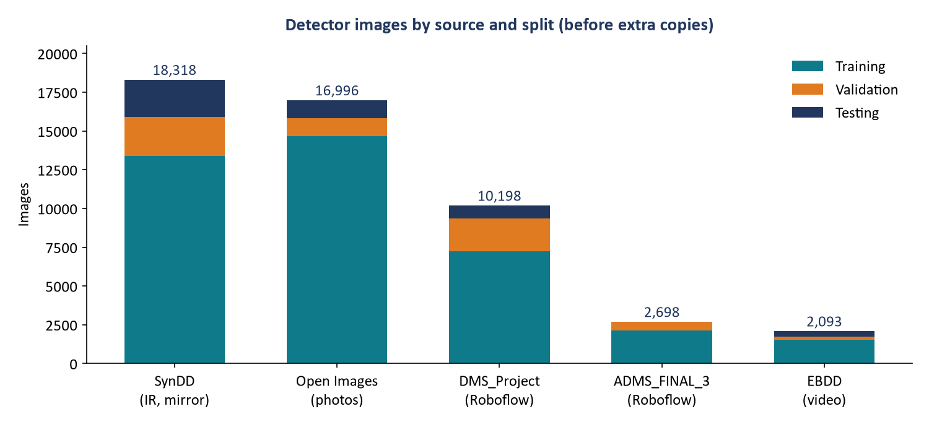
Figure 5: Detector images by source and split
Fair-testing rule
Settings (such as alarm thresholds) are chosen on the validation drivers only. The test drivers are scored once, at the end.

3.8 Size and class balance
Table 7: Final detector dataset
Split | Images | Phone boxes | Drink boxes | Food boxes | No object
Training | 53,889 | 30,193 | 47,605 | 24,786 | 9,327
Validation | 6,557 | 2,099 | 3,046 | 1,769 | 1,514
Test | 4,780 | 1,994 | 2,528 | 1,642 | 1,429

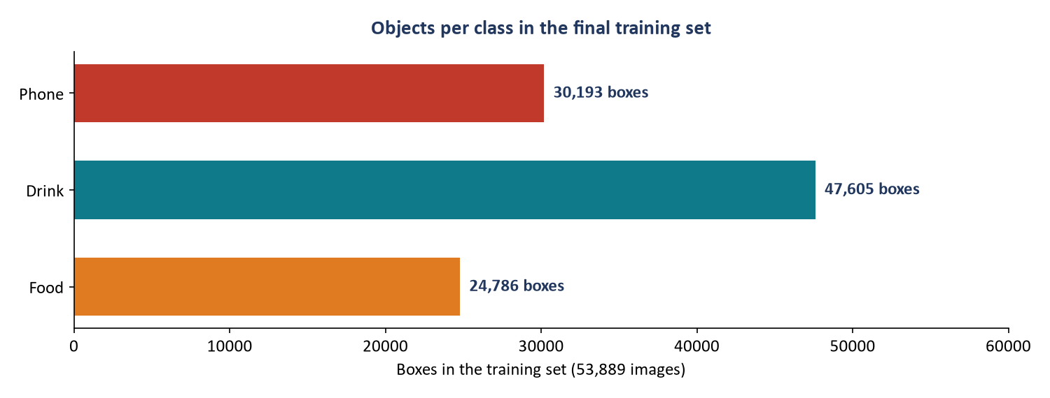
Figure 6: Objects per class in the training set
Table 8: SynDD training frames per action
Action | Frames | Note
Phone at the ear | 4,424 | Good amount
Phone in hand (texting) | 2,803 | Phone often below the camera
Drinking | 409 | Enough
Eating | 3 | Weak: food is almost never visible
Normal driving | 1,158 | No objects
Look-alikes (talking, singing, yawning, hand on head) | 4,588 | No objects

4. Progress: How It Went
Table 9: Main steps and results
# | What we did | Result
1 | Version 1: State Farm classifier | Wrong camera angle → replaced
2 | First detector, Open Images only | Found the phone in only 1–35% of car frames
3 | Downloaded SynDD (69 drivers, infrared, mirror view) and labelled 18,318 frames | Became the main dataset
4 | Merged 5 sources (detector v2b) | Phone at the ear found in 72–92% of frames
5 | Grey-only training at 512 px + tuned thresholds (v2d) | Test drivers: 80–100% of phone calls caught, 0–5 false alarms per hour
6 | Tried 8 more ideas (more views, SAM 2 boxes, fisheye...) | None was better; most added false alarms
7 | Tested on 2 unseen datasets (3MDAD, DAD) | Phones still found; many false alarms on a very different camera

Main lesson
Training data must look like our camera. Data from other angles raised false alarms. Our own recordings (Task 7) are now the most important data.

5. Data Quality and Ethics
Table 10: Quality and ethics checklist
Check | Status | Details
Test people never seen in training | Done | SynDD, EBDD and MRL split by person; 3MDAD and DAD test only
Thresholds chosen fairly | Done | Validation drivers only
Balanced classes | Partly | Phones boosted with hand copies; food is still rare in car video
Licences respected | Done | Roboflow CC BY 4.0; Open Images CC BY; SynDD, EBDD, DAD research use only
Data kept private | Done | On the project drive only, never on GitHub; EBDD password not in the code
Labels checked by a person | Planned | 495 test frames ready to check
Consent for our own recordings | Planned | Signed form before recording

6. Assumptions and Limitations
Assumptions
- The camera sits at the centre mirror and uses infrared at night.
- The car is left-hand drive, so the driver is on the right of the image.
- Acted actions (SynDD) look close enough to real ones.
Limitations
- Most video boxes were made by a model and are not yet hand-checked.
- Eating cannot be learned: food is almost never visible (3 SynDD frames).
- When texting below the camera, the phone cannot be seen; a head-down rule helps.
- On a very different camera (DAD, close-up) the steering wheel was mistaken for a phone.
- We have no recordings from our own camera yet.

7. Next Steps
- Record 10–20 volunteers with our camera, day and night (Task 7).
- Add their normal driving to training as "no phone" examples.
- Hand-check the 495 test frames.
- Collect eating video where the food is visible, or keep eating out of the alerts.

8. References
[1] D. F. Dinges, R. Grace. "PERCLOS: A Valid Psychophysiological Measure of Alertness as Assessed by Psychomotor Vigilance." US FHWA Tech Brief FHWA-MCRT-98-006, 1998.
[2] Google. MediaPipe Face Mesh V2 and BlazeFace model cards; MediaPipe Face Landmarker documentation. ai.google.dev/edge/mediapipe
[3] F. Song, X. Tan, X. Liu, S. Chen. "Eyes Closeness Detection from Still Images with Multi-scale Histograms of Principal Oriented Gradients." Pattern Recognition, 47(9):2825–2838, 2014. (CEW)
[4] R. Fusek. "Pupil Localization Using Geodesic Distance." ISVC 2018, Springer, 2018. (MRL Eye Dataset)
[5] G. Jocher, J. Qiu. Ultralytics YOLO26. docs.ultralytics.com, 2025.
[6] M. S. Rahman et al. "Synthetic Distracted Driving (SynDD2) Dataset for Analyzing Distracted Behaviors and Various Gaze Zones of a Driver." arXiv:2204.08096, 2022. Used as the AI City Challenge 2024 Track 3 data.
[7] A. Kuznetsova et al. "The Open Images Dataset V4." International Journal of Computer Vision, 128:1956–1981, 2020.
[8] DMS_Project v2. Roboflow Universe, CC BY 4.0. universe.roboflow.com/himanshis-workspace-eaqo0/dms_project-uoj4y
[9] ADMS_FINAL_3 v1. Roboflow Universe, CC BY 4.0. universe.roboflow.com/lable-hhkbv/adms_final_3-gzvfv
[10] T. Billah, S. M. M. Rahman, M. O. Ahmad, M. N. S. Swamy. "Recognizing Distractions for Assistive Driving by Tracking Body Parts." IEEE TCSVT, 29(4):1048–1062, 2019. (EBDD)
[11] I. Jegham, A. Ben Khalifa, I. Alouani, M. A. Mahjoub. "A Novel Public Dataset for Multimodal Multiview and Multispectral Driver Distraction Analysis: 3MDAD." Signal Processing: Image Communication, 88:115960, 2020.
[12] O. Köpüklü, J. Zheng, H. Xu, G. Rigoll. "Driver Anomaly Detection: A Dataset and Contrastive Learning Approach." IEEE WACV, 2021. (DAD)
[13] T. Cheng et al. "YOLO-World: Real-Time Open-Vocabulary Object Detection." IEEE CVPR, 2024.
[14] K. Zuiderveld. "Contrast Limited Adaptive Histogram Equalization." Graphics Gems IV, pp. 474–485, 1994.
[15] T. Soukupová, J. Čech. "Real-Time Eye Blink Detection using Facial Landmarks." CVWW, 2016.
[16] State Farm. State Farm Distracted Driver Detection, Kaggle, 2016. (Used in version 1 only.)

